Toft Butterfly Survey 2020

Introduction
Paradoxically, the strange coronavirus Spring and summer was in many ways a great time for wildlife. The spring of 2020 was one of the sunniest in living memory – sunnier than any other British spring on record bar three. With the whole population confined to home, many people sought diversion in nature. Wildlife Trusts reported that viewings of their webcams between March and May increased by a staggering 2000%. In Toft we may not have experienced wild goats roaming the streets (as did Llandudno) or fallow deer grazing our verges (as in east London), but many residents took a fresh interest in, and comfort from, the flora and fauna in their own back gardens.
Toft has an amazing array of talent and expertise amongst its residents, and participating in the butterfly survey we were extremely lucky to have people with vast knowledge of nature and others able to capture the images in stunning photography. So, whilst this was a very small scale survey, I for one learned a great deal from taking part and hopefully others will learn a little more about what can be found in our village.

Methodology
The survey was advertised in the Toft Village calendar and on the Next Door website (see appendix 1) and residents were invited to record on a monthly basis from April to September the different species seen in their gardens. To keep matters simple, only the species were recorded, not the number of times seen. Fourteen households expressed interest, but regular reports were received back from just six. It later transpired that two participants had done their ‘spottings’ outside their gardens (but still within Toft), so some non-garden species may make an appearance.
The findings were collated and are shown below.

Results

Number of species seen by month
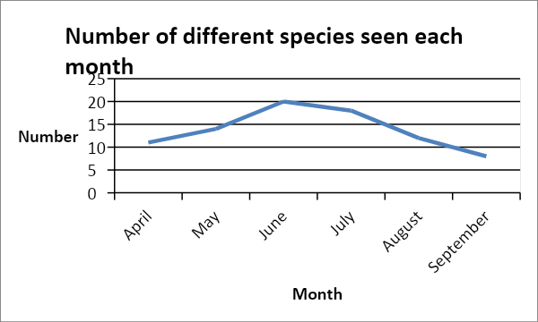
As to be expected, the summer months saw a peak in both the numbers of butterflies seen and the number of different species spotted:

Most commonly seen butterfly species

Over the whole survey period, the top ten most frequently spotted species were as follows:
- Small white – 26
- Large white – 25
- Red admiral – 19
- Small tortoiseshell – 17
- Brimstone – 16
- Peacock – 15
- Holly blue – 14
- Meadow brown – 13
- Comma – 10
- Gatekeeper/Green veined white – 8 (tie)
Several participants noted the presence of the spectacularly red coloured cinnabar moth, which would have made number 10 in the chart if it had been a butterfly.
By month, the most frequently seen species were:
Month | 1st | 2nd
April | Brimstone (6) | Small White/ Peacock/Holly Blue (5 each)
May | Large white(5) | Brimstone/holly blue (5 each)
June | Small white/meadow brown/small tortoiseshell (5 each)
July | Large white/red admiral (6 each)
Aug | Large white/red admiral (5 each)
Sept | Large white (5) | Small white/red admiral (4 each)

Total Toft sightings

The chart overleaf shows the whole range of species seen by participants over the period of the survey, including the rarer sightings; some species, moths in particular, were added to the original checklist by participants, but although they do not actually meet the definition of ‘butterflies’, they add to our knowledge of what is ‘out there’.

All butterfly sightings

SPECIES seen | Apr | May | June | July | Aug | Sept | Total seen during survey period
Large white | 2 | 5 | 2 | 6 | 5 | 5 | 25
Small white | 5 | 4 | 5 | 4 | 4 | 4 | 26
Green-veined white | 2 | 2 | 2 | 0 | 0 | 2 | 8
Brimstone | 6 | 4 | 0 | 2 | 2 | 2 | 16
Marbled white | 0 | 0 | 1 | 1 | 0 | 0 | 2
Small copper | 0 | 1 | 1 | 1 | 0 | 0 | 3
Gatekeeper | 0 | 0 | 1 | 4 | 3 | 0 | 8
Meadow brown | 0 | 1 | 5 | 5 | 2 | 0 | 13
Ringlet | 0 | 0 | 0 | 3 | 0 | 0 | 3
Speckled wood | 1 | 0 | 1 | 2 | 1 | 1 | 6
Comma | 1 | 0 | 2 | 4 | 2 | 1 | 10
Painted lady | 0 | 0 | 0 | 0 | 0 | 0
Small tortoiseshell | 3 | 2 | 5 | 4 | 3 | 0 | 17
Red admiral | 0 | 1 | 3 | 6 | 5 | 4 | 19
Peacock | 5 | 2 | 0 | 4 | 2 | 2 | 15
Common blue | 0 | 2 | 1 | 1 | 1 | 0 | 5
Holly blue | 5 | 4 | 3 | 1 | 1 | 0 | 14
Orange tip | 4 | 3 | 0 | 0 | 0 | 0 | 7
Cinnabar Moth | 2 | 3 | 2 | 2 | 0 | 0 | 9
Small skipper | 0 | 0 | 2 | 3 | 0 | 0 | 5
Small heath | 0 | 0 | 1? | 0 | 0 | 0 | 1?
Magpie Moth | 0 | 0 | 1 | 0 | 0 | 0 | 1
Orange Underwing Moth | 0 | 0 | 1 | 0 | 0 | 0 | 1
Dark Arches Moth | 0 | 0 | 1 | 0 | 0 | 0 | 1
Essex Skipper |  |  | 1 |  | 0 | 0 | 1
Silver washed fritillary |  |  |  | 1 | 0 | 0 | 1
TOTAL NO. OF SPECIES SEEN BY MONTH | 11 | 14 | 20 | 18 | 12 | 8

Comparisons with other surveys

Although this is a small study, these findings can be seen in the context of bigger studies. Wildlife charity Butterfly Conservation has recently released data about the number of butterflies counted in this year’s national Big Butterfly Count (17th July – 9th August 2020). Worryingly this summer’s Count has seen a reduction in the average number of butterflies logged per count of minus 34% in comparison with 2019, and the lowest average number of butterflies logged overall since the event began eleven years ago. In all, during this year’s Big Butterfly Count, over 1.4 million butterflies were counted across the UK.

‘Big Butterfly Count’ results – England 2020

· Large White was the most abundant butterfly in the 2020 Big Butterfly Count in England, numbers were up by 37% on 2019 and this summer was the fourth best year for this butterfly. (This is comparable to Toft’s results.)
· Numbers of Common Blue were up slightly on 2019 levels, however, 2020 was the fourth worst year for this butterfly in the Big Butterfly Count. Holly Blue had a welcome bounce back from 2019, with 2020 being the fourth best year for this species. Small Copper was up on previous years and had its second-best year in the Big Butterfly Count since the launch of the project in 2010. (Holly Blue’s also did well in Toft).
· As per the UK level analysis, Painted Lady numbers were down massively due to 2019 being a Painted Lady migration year. (None seen at all in Toft).
· Patterns of change across England are broadly similar to those of the UK level analysis, with the ‘browns’ faring poorly. Speckled Wood experienced its worst year in the Big Butterfly Count since the start of the project, and Meadow Brown, Gatekeeper, Ringlet and Marbled White all had their second to worst years in the Big Butterfly Count series. (Low numbers of each seen in Toft, especially Marbled Whites.)
· The average number of butterflies per count was 10.9, this is the lowest average over the history of the Big Butterfly Count.

Finally…

We are very lucky to have in Toft our own professional nature photographer, Ann Miles, who has been kind enough to share her photographic record of butterflies she has spotted in Toft during our survey – see overleaf.
Thanks to all who participated, enjoy…!

Gill Pugh
October 2020
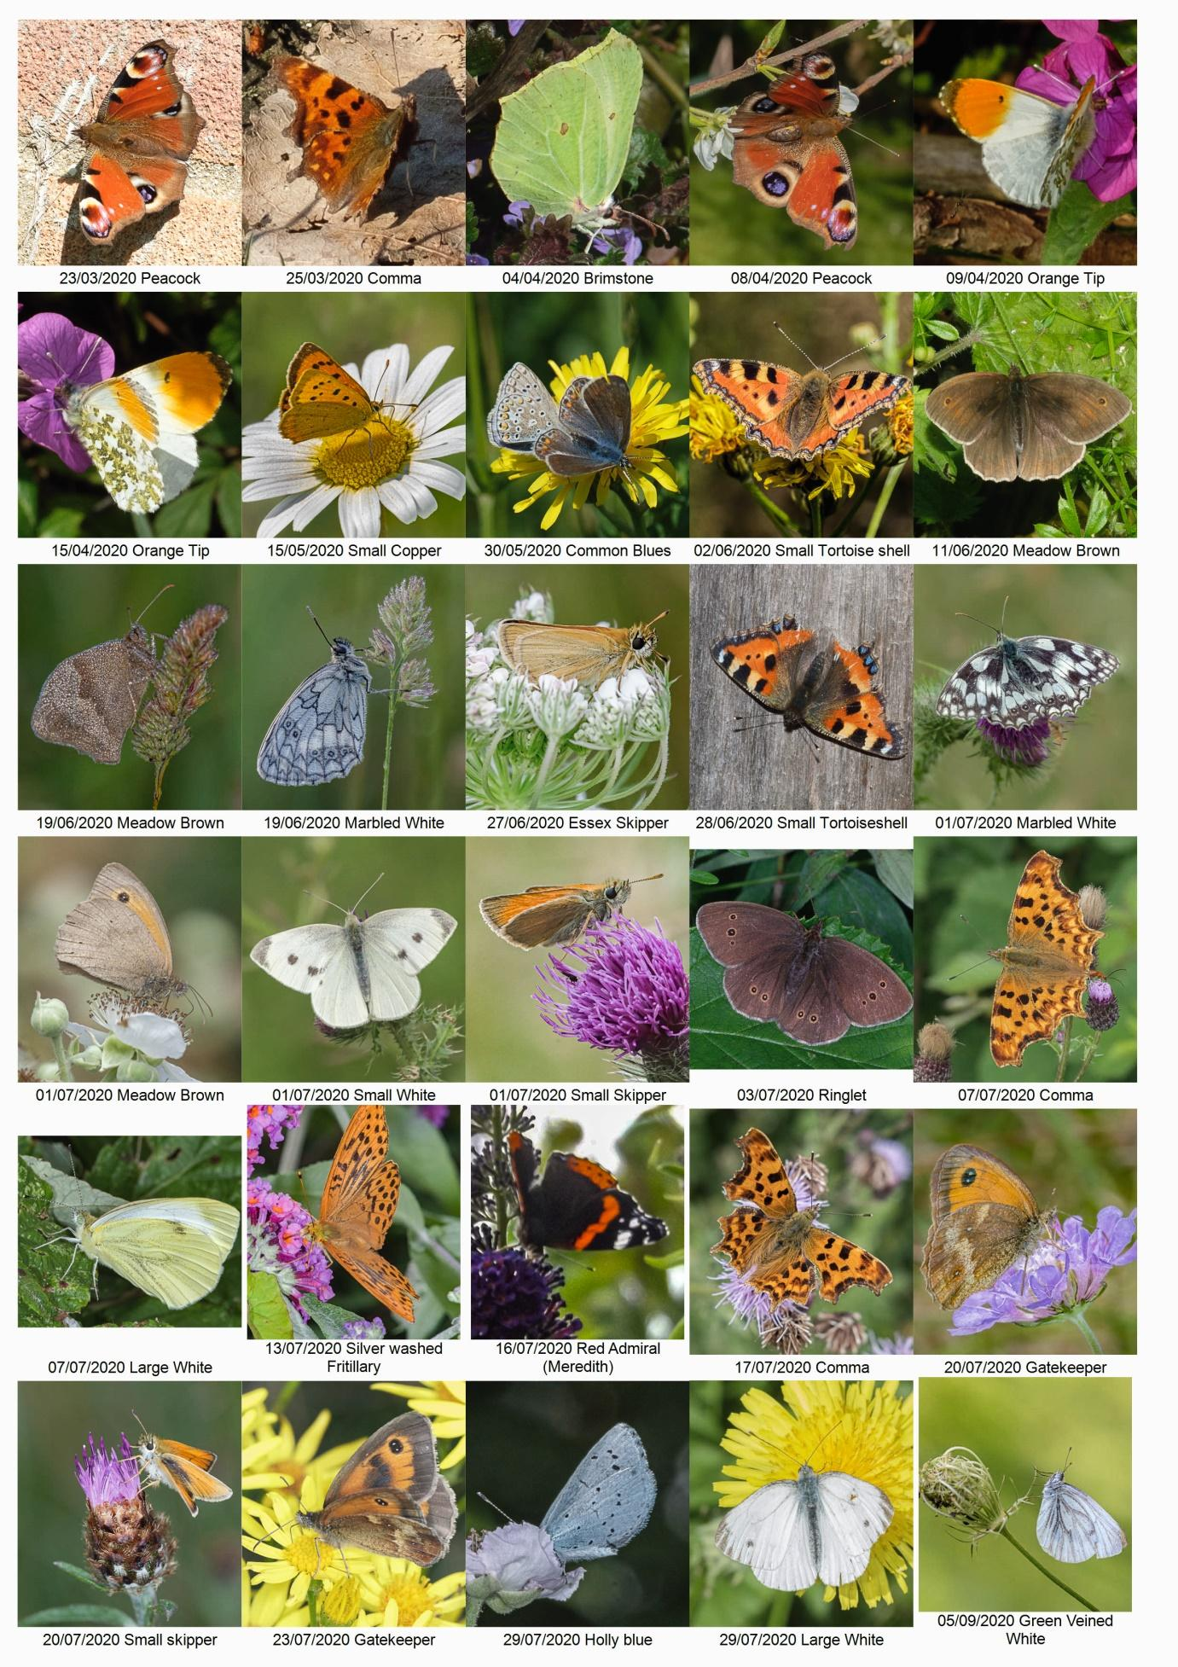

Appendix 1


